**Virtual Machines (VMs)**

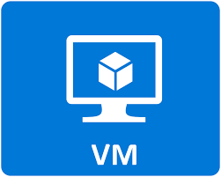

**Virtual Machines (VMs)** are software-based emulations of physical computers that run an operating system and applications independently. They allow multiple OS instances to run on a single physical machine using a hypervisor.

**Virtual Machines (VMs)** are a key component of **Infrastructure as a Service (IaaS).**

1. IaaS provides **virtualized computing resources** over the internet — such as virtual machines, storage, and networks — allowing users to run their own OS and apps.
2. When you use a VM from a cloud provider (like AWS EC2, Azure VM, or Google Compute Engine), you're **renting infrastructure** — not a full platform (like PaaS) or an app (like SaaS).
3. In IaaS, **you control the OS, runtime, and applications** — which is exactly what VMs give you. The cloud provider manages the hardware and virtualization layer, while you manage everything inside the VM.